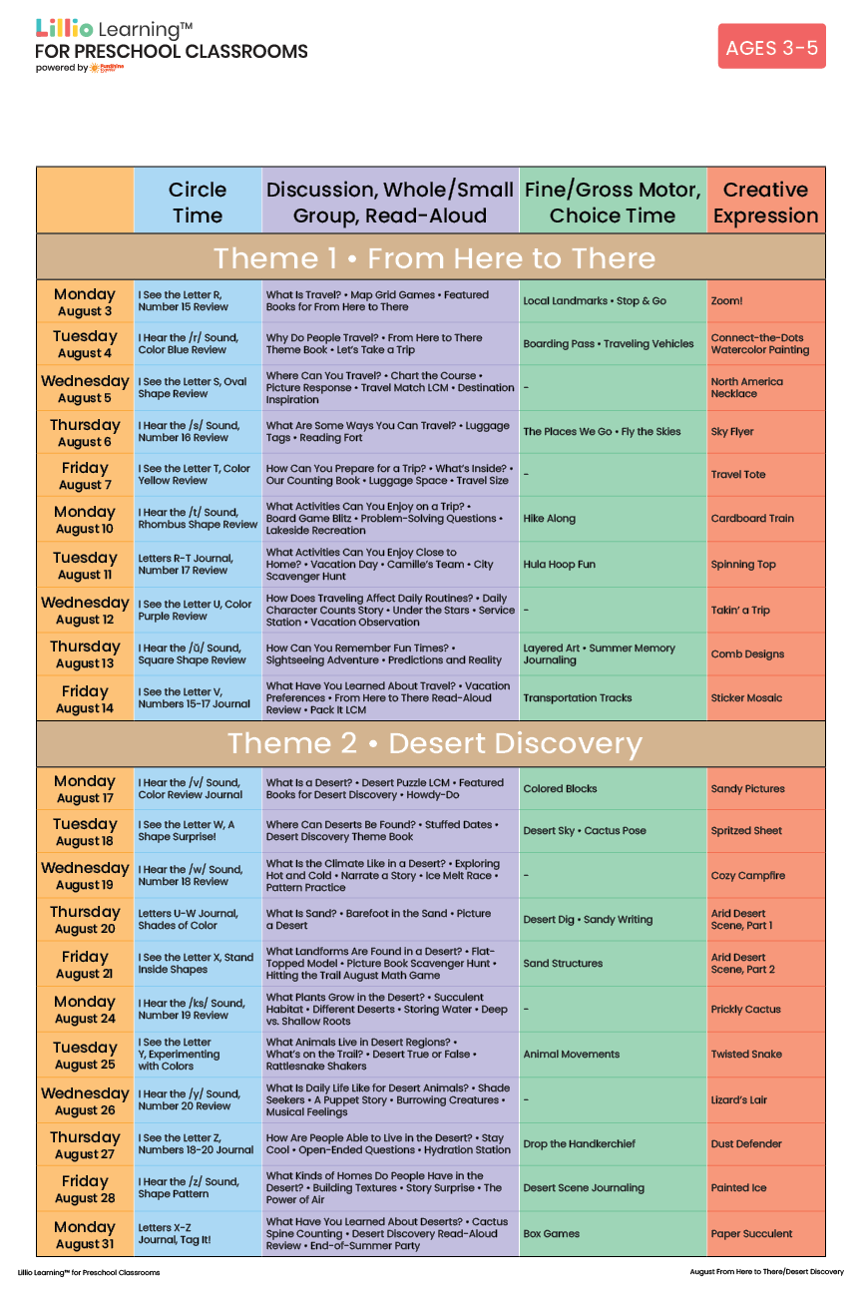
Add Your Name/Logo Here
August 2026

